in-class practice for CAP Empirical Methods – Day #2

I. Meltzer HY et al. Clozapine treatment for suicidality in schizophrenia: International Suicide Prevention Trial (InterSePT). Arch Gen Psychiatry. 2003;60(1):82-91. doi:10.1001/archpsyc.60.1.82

Were there a statistically significant differences in _____?
“significant suicide attempts”
suicide deaths
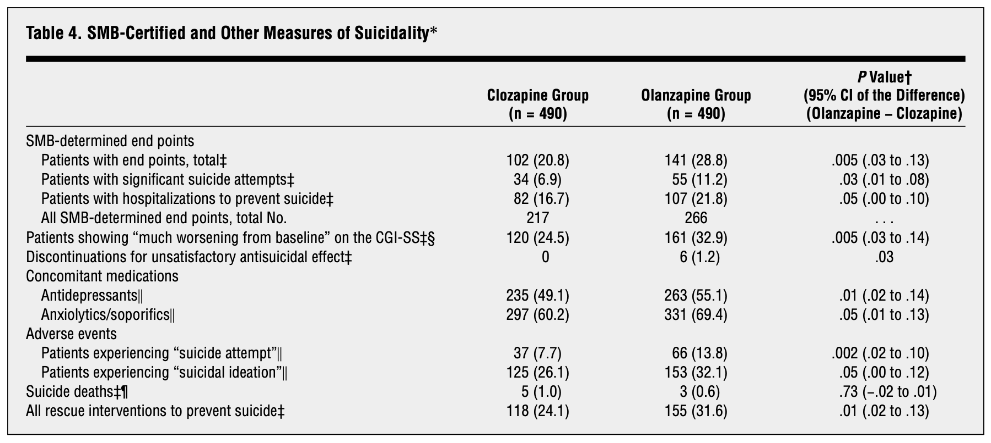

II. Study 329.
Keller MB, Ryan ND, Strober M, et al. Efficacy of paroxetine in the treatment of adolescent major depression: a randomized, controlled trial. J Am Acad Child Adolesc Psychiatry. 2001;40(7):762-772. doi:10.1097/00004583-200107000-00010

Was there a statistically significant difference between paroxetine and placebo for “response” (defined as HAM-D <= 8 or 50% reduction in baseline HAM-D week 8 endpoint)?

What about changes on the depressed mood item? (background about it on next page)
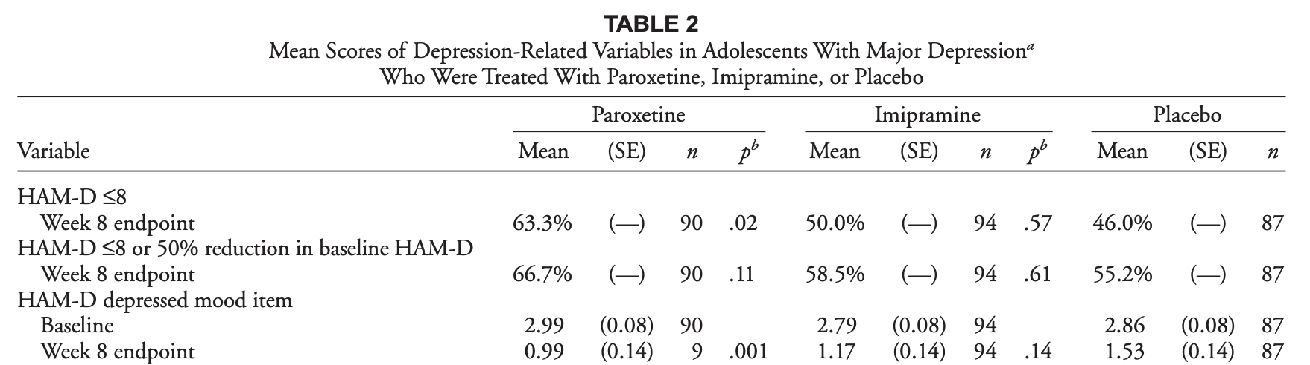

Background: Depressed mood item is rated by the clinician on a 0-4 scale based on these criteria:
0 = absent
1 = these feeling states indicated only on questioning
2 = these feeling states reported spontaneously, verbally
3 = communicates the feeling states non-verbally: facial expression, posture, voice, tendency to weep
4 = patient reports virtually only these feeling states in spontaneous verbal and non-verbal communication

III. Adolescent TMS study from class 1
Croarkin PE, et al. Left prefrontal transcranial magnetic stimulation for treatment-resistant depression in adolescents: a double-blind, randomized, sham-controlled trial. Neuropsychopharmacology. 2021;46(3):462-469. doi:10.1038/s41386-020-00829-y

Was active treatment statistically significantly better than sham treatment on the HAM-D-24 (change from baseline)?
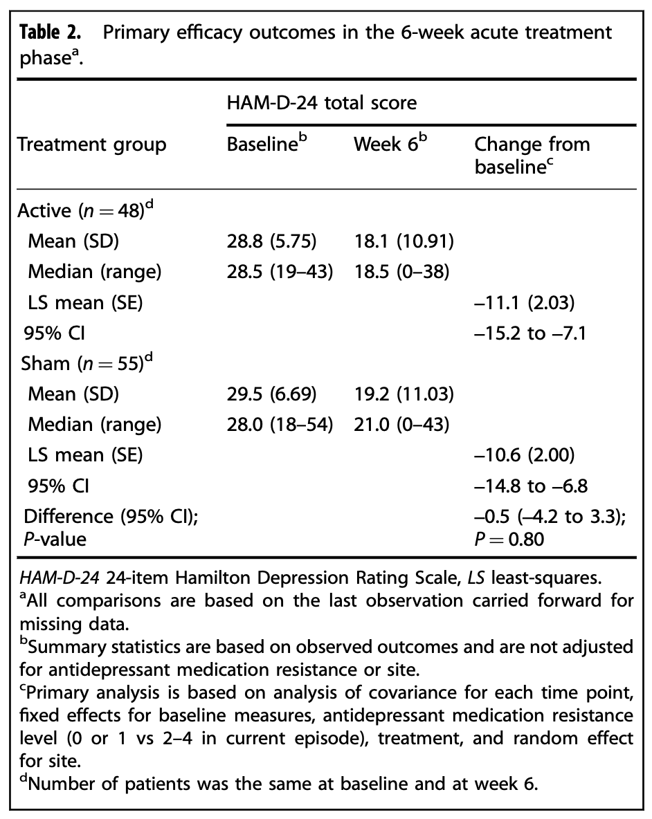

Practice for CAP Empirical Methods – Day #2

1. Explain these concepts in your own words, ideally to a real person who might have follow-up questions. If you have no friends, discuss with your cat.

I. number needed to treat
II. clinical significance
III. p-value
IV. statistical significance
V. confidence interval

2. Find an example in a newspaper or scientific paper where they say “__% change.”Was it an absolute change or relative?

3. These two distributions have the same mean but different standard deviations.
a. Which has a larger standard deviation? Explain it to a hypothetical med student.
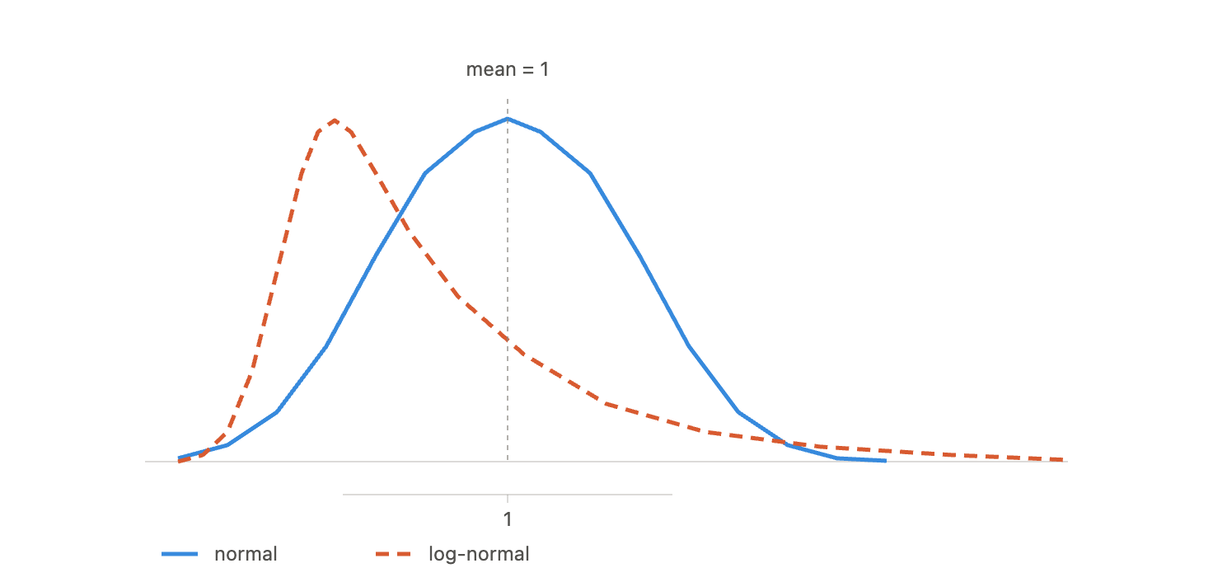
b. Can you think of any health care data that has right skew like the dashed distribution? (e.g. where most people have very low values and a small fraction have very large values)

4. Some resident who will remain nameless told me that MAT for opioid use disorder reduced overdose deaths by ~50% and had an NNT = ~2. Here’s some data from cohort studies estimating the risk of death on buprenorphine vs not on MAT. They are probably biased but no one is going to do an RCT of MAT vs placebo (why?) so run with this and calculate the NNT to prevent one death.

 | Death risk (per year)
buprenorphine | 3.0%
no MAT | 4.9%

Larochelle MR et al. Medication for opioid use disorder after nonfatal opioid overdose and association with mortality: a cohort study. Ann Intern Med. 2018;169(3):137-145. doi:10.7326/M17-3107

5. Hammad et al. (2006) pooled data on “suicidal behavior or ideation” from all pediatric antidepressant trials submitted to the FDA. They found 61 of 2414 patients on a drug had “suicidal behavior or ideation” compared to 26 of 2073 patients on placebo.

a. calculate the NNH
b. how many adolescents have you prescribed an SSRI in the past year? how many will you over your career? how many can you expect to be harmed?
c. how many patients do you think had “ideation” and how many had “behavior?”
Explain why this matters to a hypothetical med student

Hammad TA, Laughren T, Racoosin J. Suicidality in pediatric patients treated with antidepressant drugs. Arch Gen Psychiatry. 2006;63(3):332-339. doi:10.1001/archpsyc.63.3.332

6. True/False: If the 95% confidence interval for the effect of a drug doesn’t include zero then the p-value < 0.05 for the null hypothesis.

